Form-B (EPI)

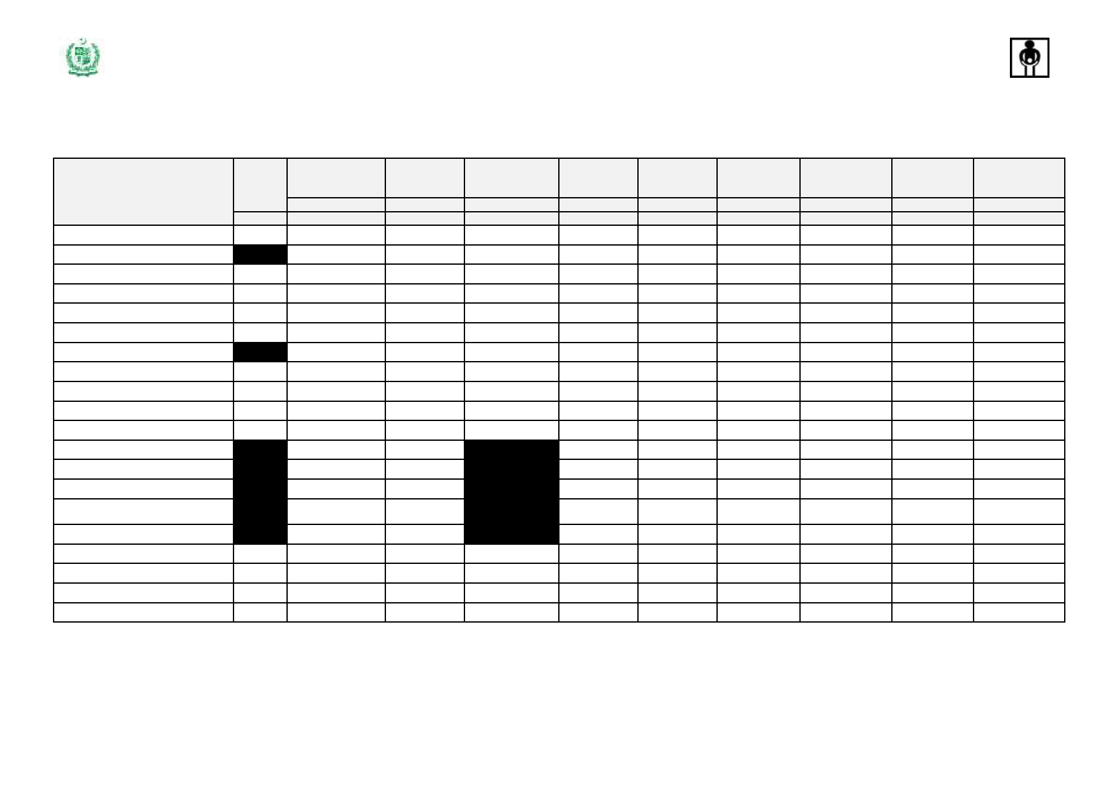

***Expanded Program on Immunization, Government of Pakistan***

**Consumption & Requisition Form**

**Routine Immunization**

**Health Facility/Store: ___________________ UC _______________ Tehsil/Taluka: ____________________ District: _____________________ Province:_________________ Date:______________(MM/YY)**

**Product**

**Dose**

**per Vial**

**A**

**Opening Balance**

**Doses/Nos.**

**B**

**Received**

**Doses/Nos.**

**C**

**Children**

**Vaccinated/Doses**

**Administered**

**Doses/Nos.**

**D**

**Vials Used**

**Vials/Nos.**

**E**

**Unusable**

**Vials**

**Vials/Nos.**

**F**

**Closing Balance**

**Vials/Nos.**

**G**

**Max. Stock Level**

**Vials/Nos.**

**H**

**Request (I = H - G )**

**Vials/Nos.**

**I**

**Replenishment**

**Vials/Nos.**

**J**

**B CG**

**DIL BCG**

**tOPV**

**Pentavalent**

**Pneumococcal (PCV10)**

**Measles**

**DIL Measles**

**TT TT**

**HBV (Birth dose)**

**IPV**

**AD Syringes 0.5 ml**

**AD Syringes 0.05 ml**

**Recon. Syringes (2 ml)**

**Recon. Syringes (5 ml)**

**Safety Boxes**

20

20 01 02 10

10 20 10 10

Note: i. Use blank rows, if needed to add more than one batch received for one product/new products

ii. This report to be sent every month by every HF to the district by 7th of next month and by every district to the province by 10th of next month. Provinces will send this to Federal EPI by every quarter.

Prepared By ___________________________ Medical Officer / In-charge (Signature) ______________________ ` Date: _________________________